

**VEHICLE RENTAL SYSTEM WITH MOBILE APP SUPPORT**

Capstone Project Presented to

CEDAR College, Inc.

National Highway

Cadiz City, Negros Occidental

In Partial Fulfillment of the

Requirements for the Degree of

Bachelor of Science in Information Technology

Gennie Rose C. Delcoro

Rev S. Demavivas

Wilma G. Guarino

Mary Rose P. Porponio

March 2025

**TABLE OF CONTENTS**

**CHAPTER 1**

**Introduction…………………………………………………………………………………….…1**

Project Context…………………………………………………………………………………..…1

Project Description…………………………………………………………………………………1

Objectives……………………………………………………………………………….…………3

Scope and Limitation……………………………………………………………………...….……4

Definition of Terms…………………………………………………………………………...……5

Review of Related Literature……………………………………………………………………....7

Conceptual Framework………………………………………………………………….…………………….11

References………………………………………………………………………………………...13

**CHAPTER II**

**Methodology…………………………………………………………………………………..…16**

Research Design………………………………………………………………………………..…16

Local of the Study………………………………………………………………………………...16

Use Case Diagram………………………………………………………………..……………….17

Theoretical Framework…………………………………………………………………………...18

Requirement Cost…………………………………………………………………………………19

Gantt Chart………………………………………………………………………………………..21

System Prototype…………………………………………………………………………………22

Data Flow Diagram……………………………………………………………………………….23

Data Flow Diagram Level 0………………………………………………………………………24

ER Diagram………………………………………………………………………………………25

System Architecture………………………………………………………………………………26

Project Evaluation and Review Technique……………………………………………………….27

Critical Path Method……………………………………………………………………………...28

Cost-Benefit Analysis…………………………………………………………………………….29

Return of Investment…………….……………………………………………………..…………30

**CHAPTER III**

**Treatment of Data……………………………………………………………………………….31**

Projection…………………………………………………………………………………………50

**CHAPTER IV**

**Conclusion……………………………………...………………………………………………..51**

Recommendation…………………………………………………………………………………52

**1**

**CHAPTER I**

**INTRODUCTION**

**Project Context**

The vehicle rental sector is vital in meeting mobility needs, especially in communities where quick and efficient transportation options are essential. Traditional rental systems for tricycles often rely on manual processes, such as face-to-face bookings and limited payment options, causing inefficiencies for operators and inconvenience for customers.

The Vehicle Rental System with Mobile App Support addresses these challenges by streamlining the rental process. Customers can browse vehicles, make reservations, process payments, and manage bookings in real time. Owners and administrators benefit from efficient rental request management, vehicle monitoring, and seamless transactions, ensuring accessibility and a hassle-free experience for all.

**Project Description**

The Vehicle Rental System with Mobile App is a comprehensive platform designed to facilitate the rental of vehicles such as tricycle through an easy-to-use mobile application. The system enables users to search for available vehicles, view pricing, make reservations, and process secure payments. Vehicle owners can list their vehicles, manage bookings, and track their rentals through an admin interface.

The mobile app will offer key features such as user registration, browsing and searching for vehicles, real-time availability tracking, and a booking system with integrated payment options. Users can also review their rental history and receive notifications about upcoming bookings and

**2**

promotions. For vehicle owners, the platform provides tools to add and manage vehicle listings, monitor bookings, and generate reports on revenue and vehicle usage.

The app will be developed using modern technologies to ensure a smooth user experience, data security, and scalability. It will target both individual users looking for convenient rental options and vehicle owners or rental companies wanting to expand their reach in the market.

**3**

**Objectives**

The primary objective of the Vehicle Rental System with Mobile App is to streamline the vehicle rental process for both users and vehicle owners. Furthermore, the specific objectives are as follows:

1. To establish a centralized vehicle management system that allows vehicle owners to monitor the availability and status of their vehicles in real-time, ensuring that vehicles are always ready for rental and reducing issues related to overbooking or under-utilization.
2. To automate the vehicle booking process and payment handling, minimizing manual errors and enhancing the speed and accuracy of bookings, ultimately improving user satisfaction and reducing the workload for vehicle owners.
3. To enhance user experience through real-time notifications and updates on booking statuses, vehicle availability, and upcoming rental periods, ensuring that users are always informed and engaged.

**4**

**Scope and Limitations**

The system will feature real-time vehicle availability displays, secure booking and payment processing, GPS tracking for rented vehicles, and a comprehensive user management system.

Additionally, the project includes mobile app integration for on-the-go access and real-time notifications such as booking confirmations and reminders. Administrators will benefit from a vehicle management dashboard, allowing them to monitor rentals and track vehicles, ensuring efficient operations. The system will support various types of vehicles and integrate with secure payment gateways to ensure seamless transactions for users. However, there are several limitations to the project.

The system will not handle vehicle maintenance, insurance management, or hardware-related services. Technical challenges include potential issues with scalability, especially during high traffic or large fleet management, and device compatibility concerns with older or unsupported systems. Furthermore, the system's reliance on real-time GPS and payment gateway data introduces potential delays or inaccuracies. The project also faces resource limitations, such as budget and time constraints, which may affect advanced feature development and testing Compliance with data privacy laws and legal liability regarding vehicle misuse are additional concerns that must be addressed.

**5**

**Definition of Terms**

**1. User Registration and Authentication System-** Enables personalized access, protects user data, and ensures only authorized users can book or manage vehicles**.**

Operationally, manages secure user profiles, including registration, login, and password recovery. Implements multi-factor authentication (MFA) and monitors suspicious activities.

**2. Vehicle Search and Filtering System-** Simplifies the selection process by allowing users to find vehicles that meet their specific needs quickly.

Operationally, provides filters for vehicle type, price range, availability, location, and features. Updates the search results in real time for improved user experience.

**3. Real-Time Vehicle Availability Tracking-** Prevents double bookings and ensures users access accurate inventory information.

Operationally, continuously syncs availability data across user platforms and backend systems. Instantly flags unavailable vehicles to avoid scheduling conflicts.

**4. Booking and Scheduling Module-** Streamlines the reservation process and eliminates manual handling of bookings.

Operationally, automates reservation workflows, manages booking changes, and synchronizes with calendar integrations. Handles cancellations and rescheduling seamlessly.

**5. Payment Gateway Integration-** Facilitates seamless and secure payment transactions for users and businesses.

Operationally, Support payment methods like PayPal, processes payments in compliance with security standards, and generates receipts automatically.

**6. Location Tracking and GPS Integration-** Enhances user convenience by guiding them to their reserved vehicles and tracking the vehicles during use.

Operationally, provides turn-by-turn navigation to vehicles, real-time location updates during trips, and geo fencing alerts for unauthorized movements.

**6**

**7. Fleet Management System-** Ensures vehicles are in optimal condition and improves resource utilization for the business.

Operationally, monitors vehicle maintenance schedules, tracks performance metrics (fuel usage, mileage), and facilitates efficient dispatching.

**8. Notifications and Alerts System-** Keeps users informed and engaged while reducing missed bookings or payments.

Operationally, sends timely updates on booking confirmations, payment statuses, maintenance reminders, and promotional offers via email, SMS, or push notifications.

**9. Customer Feedback and Review System-** Builds customer trust, helps improve service quality, and provides transparency.

Operationally, collect user ratings and reviews post-transaction, analyzes feedback to identify service gaps, and displays aggregated ratings for vehicles or services.

**10. Analytics and Reporting Tools-** Helps businesses make informed decisions, improve strategies, and maximize profitability.

Operationally, tracks key performance indicators (KPIs), generates reports on bookings, revenue, and usage patterns, and provides insights for trend forecasting and strategic planning.

**7**

**Review of Related Literature**

According to Albino, M. (2021) A system that will manage the activities of a car rental was the primary objective of this research study. With the implementation of the proposed car rental management system with a scheduling algorithm, the transaction of the business will become easy and reliable.

The developed system will enable the users to effectively manage the transaction, scheduling, and inventory of cars of the car rental business. The researchers used Extreme Programming Methodology since this type of software development methodology helped the researchers in the planning, designing, implementation, and maintenance of the developed system.

Alegre, C. B., Cortez, M. M., Pepito, A. M., Soleno, K. A., & Intal, G. L. (2024) Demands and opportunities for mobility services are increasing due to the country's poor urban mobility readiness.  A way to resolve the issues accompanying the need for mobility services is to promote a shared economy through vehicle sharing. Sharing economy is an alternative to traditional consumption, where underutilized assets and services are offered to potential users with or without a fee.  MobiLease: Wheels on Lease is a mobile application aggregating vehicular resources and complementary vehicle maintenance and fleet management services to provide alternative transportation to individuals within the National Capital Region.

Assyifa, R., Tao, S. J., &Irianto, S. Y. (2020) Designing and Implementing Car Rental System research paper addresses the inefficiencies faced by tourists and local rental service providers in the vehicle rental sector of Siargao Island in the Philippines. Despite the thriving tourism industry in the island, the current manual processes for vehicle rentals are fraught with challenges such as unreliable service, booking difficulties, and inefficient fleet management.

**8**

Aulia, N. F., & Candra, F. (2023) Management of rental transactions is currently done manually by recording customer data and storing customer guarantees in the archives that have been provided. Problems arise when the data is lost or damaged while the car is on the customer's side. In addition, other issues arise when a customer cancels suddenly on that day, or the customer's uncertainty about car rental will impact other customers who are serious about renting a car at that time. From these problems, we need a system that can automatically manage, store, and manage car rental transactions using Android. The development method in this study uses the prototype development method. The Prototype is a development method that involves users in system development. Based on the research results, we get a very good interpretation of the standard quality of the ISO 25010 system test, functional, performance, reliability, maintainability, security, usability, and efficiency

F. D. P. Anglo et al (2022) UV Express is one of the most used modes of public transportation in the Philippines. However, the inconvenience in commuting, such as long queues of passengers at UV Express terminals and extended waiting time for UV Express drivers and passengers, is still present. The Book-Express aims to help UV Express, which operates on a terminal-to-terminal basis, by providing a reservation and booking system through a website and mobile application. The system’s primary functionalities were validated through user acceptance testing using the metrics of functionality, usability, reliability, performance, and supportability.

In addition, Golbabaei, F., Yigitcanlar, T., & Bunker, J. (2020) This study aims to investigate and map out the service attributes and impacts of SAVs on urban mobility, infrastructure and land use, travel behavior, and the environment. As the methodological approach, the paper adopts the systematic literature review technique. The study findings reveal that providing dynamic

**9**

ridesharing services could result in significant reduction of SAV fleet size, congestion, travel cost, parking demand, vehicle ownership, and emissions.

Hui, Y., Wang, Y., Sun, Q., & Tang, L. (2019) Considering that car-sharing in China has just started, which is not widely used and most cities are still in rapid development of private motorization, the private car ownership level is not high. At the same time, the willingness to support cars is a will of the future, under the policy of the private car limit, the available transit system, the travel costs, etc. So that, in the aspect of owning a car, the actual effects will take a few years to show. It is difficult to assess the direct impact of car-sharing on the ownership of private cars.

Krisnayana, I. G. P. (2024) The shift in tourist interest from initially using transportation services through travel agents to now preferring to rent vehicles themselves has become evident. With the increasing number of consumers requiring car rental services and companies expanding their fleet sizes, it is undeniable that the associated risks also increase each year. Therefore, the purpose of this research is to explore the complex risks to vehicle units in car rental companies in Bali and to determine strategies and steps to improve the security quality of vehicle units in these companies. This study employs a descriptive qualitative method with an enterprise risk management approach, which includes risk identification, risk analysis, risk assessment, risk management, and risk monitoring.

Mahi, S. H., Maliha, U. H., & Sakib, S. (2020) This research paper aims to develop an online car trading and rental system. It’s an online marketplace where anyone can buy, sell or rent cars using this website and application. This system will help the users to rent cars when needed. It can also help user to give their idle car in rent which will give them an extra bit of income. They can also

**10**

sell their used car to others. Users can also buy new or used car directly using this system in a cheaper way. This System has both Website and Android interface. Customers can use both according to their purpose.

Zhang, J., Li, F., Zhang, H., Li, R., & Li, Y. (2019) With the development of vehicle intelligence technology, the combination of network and vehicle becomes inevitable, which brings much convenience to people. At the same time, hackers can also use technical vulnerabilities to attack vehicles, leading to severe traffic accidents and even vehicle crash. Based on this situation, the vehicle information security protection techniques have drawn great attention from researchers. This paper studies the vehicle intrusion detection system  (IDS) based on the [neural network algorithm](https://www.sciencedirect.com/topics/engineering/artificial-neural-network) in [deep learning](https://www.sciencedirect.com/topics/computer-science/deep-learning), and uses [gradient descent](https://www.sciencedirect.com/topics/computer-science/gradient-descent) with momentum (GDM) and [gradient descent](https://www.sciencedirect.com/topics/engineering/gradient-descent) with momentum and adaptive gain (GDM/AG) to improve the efficiency and accuracy of IDS. The accuracy and efficiency of the proposed model are validated and evaluated by using real vehicles at the end of the paper

**11**

**Conceptual Framework**

|  |  |  |
| --- | --- | --- |
| **INPUT** | **PROCESS** | **OUTPUT** |
| * User Registration * User Location * Booking Details * Payment Details * Notifications | * User Authentication * Real-Time Tracking * Booking Management * Payment Processing * Notification Updates | * User Account Created * Location Details * Booking Confirmation * Payment Receipt * Real-Time Updates |

Input:

This section encompasses the essential data and information provided by users to initiate the app's functionality:

* User Registration: Information like name, contact number, and email address.
* User Location: GPS coordinates or manually entered address.
* Booking Details: Selected tricycle type, pickup and return time.
* Payment Details: GCash account details for the transaction.
* Notifications: System sends reminders or updates.

**12**

Processes:

* User Authentication: Verify registration or login credentials.
* Real-Time Tracking: Use GPS to locate the nearest available tricycle and show pickup points.
* Booking Management: Reserve the selected tricycle for the specified time.
* Payment Processing: Validate and process payment via GCash.
* Notification Updates: Alert user about booking status, trip updates, or changes.

Output:

* User Account Created: Successful registration or login confirmation.
* Location Details: Accurate tricycle pickup/drop-off instructions.
* Booking Confirmation: Display booking ID, tricycle details, and pickup/return schedule.
* Payment Receipt: Provide a digital receipt and payment confirmation.
* Real-Time Updates: User stays informed about their booking and trip status.

.

**13**

**REFERENCES**

* Albino, M. (2021). *Development of Car Rental Management System with Scheduling Algorithm.*

Retrieved From: <https://ssrn.com/abstract=3849830>

Date Accessed: September 08, 2024

* Alegre, C. B., Cortez, M. M., Pepito, A. M., Soleno, K. A., & Intal, G. L. (2024). *Development of Strategies and Business Model Canvas for MobiLease: Wheels on Lease Mobile Application*. In Proceedings of the 2024 15th International Conference on E-Education, E-Business, E-Management and E-Learning

Retrieved From: <https://doi.org/10.1145/3670013.3670039>

Date Accessed: September 24, 2024

* Assyifa, R., Tao, S. J., &Irianto, S. Y. (2020). *Designing and Implementing Car Rental System*. In Proceeding International Conference on Information Technology and Business

Retrieved From: [https://www.researchgate.net/profile](https://www.researchgate.net/profile/Riah-Encarnacion-2/publication/381175233_Revolutionizing_the_Rental_Services_in_Siargao_Island_Basis_for_Developing_an_Online_Vehicle_Rental_Management_System/links/666ad9ffde777205a32be7c2/Revolutionizing-the-Rental-Services-in-Siargao-Island-Basis-for-Developing-an-Online-Vehicle-Rental-Management-System.pdf)

Date Accessed: September 22, 2024

* Aulia, N. F., & Candra, F. (2023). *Design Android-Based Car Rental Management Application Using Prototype Method.*International Journal of Electrical, Energy and Power System Engineering

**14**

Retrieved From: <https://doi.org/10.31258/ijeepse.6.3.176-182>

Date Accessed: September 13, 2024

* F. D. P. Anglo et al (2022). *"BOOKEXPRESS: A Web and Mobile Based UV Express Reservation and Booking System with Data Analytics”,*2022 IEEE 14th International Conference on Humanoid, Nanotechnology, Information Technology, Communication and Control, Environment, and Management *(HNICEM)*, Boracay Island, Philippines, 2022.

Retrieved From: <https://www.mdpi.com/2071-1050/12/19/8125>

Date Accessed: September 12, 2024

* Golbabaei, F., Yigitcanlar, T., & Bunker, J. (2020*). The role of shared autonomous vehicle systems in delivering smart urban mobility: A systematic review of the literature.* International Journal of Sustainable Transportation

Retrieved From: <https://doi.org/10.1080/15568318.2020.1798571>

Date Accessed: September 24, 2024

* Hui, Y., Wang, Y., Sun, Q., & Tang, L. (2019). *The Impact of Car‐Sharing on the Willingness to Postpone a Car Purchase: A Case Study in Hangzhou, China.*Journal of Advanced Transportation

Retrieved From: <https://doi.org/10.1155/2019/9348496>

Date Accessed: September 24, 2024

**15**

* Krisnayana, I. G. P. (2024*). Risk Management and Service Management Strategies for Car Rental in Improving Vehicle Security Quality for the Company.* Eduvest-Journal of Universal Studies

Retrieved From: <https://doi.org/10.59188/eduvest.v4i7.1638>

Date Accessed: September 15, 2024

* Mahi, S. H., Maliha, U. H., & Sakib, S. (2020). *Development of Web and Mobile Application Based Online Buy, Sell and Rent Car System*. In 2020 Advanced Computing and Communication Technologies for High Performance Applications (ACCTHPA).

Retrieved From: <https://doi.org/10.1109/ACCTHPA49271.2020.9213208>

Date Accessed: September 24, 2024

* Zhang, J., Li, F., Zhang, H., Li, R., & Li, Y. (2019). *Intrusion detection system using deep learning for in-vehicle security.*

Retrieved From: <https://doi.org/10.1016/j.adhoc.2019.101974>

Date Accessed: September 24,2024

**16**

**CHAPTER II**

**METHODOLOGY**

**Research Design**

This study employs a qualitative research approach to understand the requirements and preferences of vehicle rental users and providers for a mobile app-supported system. By conducting interviews and surveys, the research will gather in-depth insights into user experiences, desired features, and challenges in the current rental process. This descriptive analysis will guide the design and development of a user-centered mobile application, focusing on improving the convenience, efficiency, and accessibility of vehicle rentals for customers, while also streamlining management processes for providers. Ultimately, the project aims to create an innovative, responsive system that aligns closely with the practical needs and preferences identified in the study.

**Locale of the Study**

The research will be conducted at Cadiz Franchising and Regulatory Board, located at Cabahug Street in Cadiz City, Negros Occidental, Philippines.

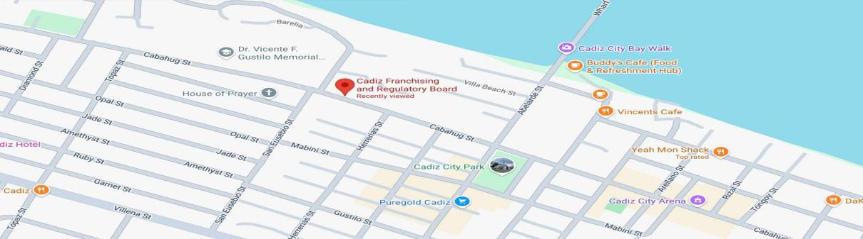

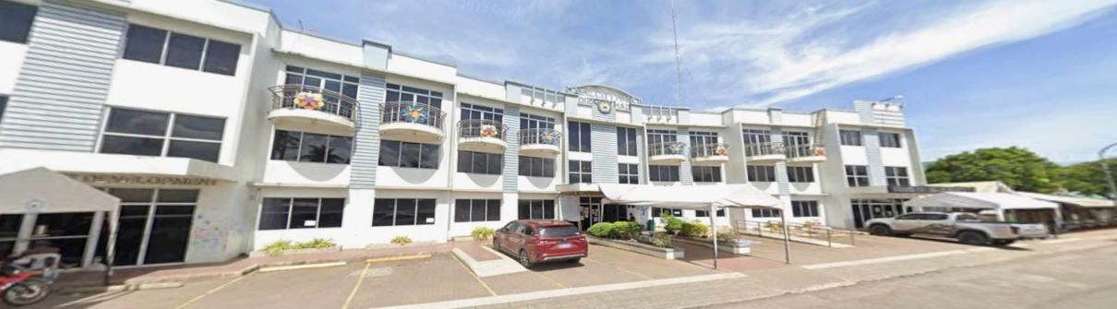

**17**

**Use Case Diagram**

**Vehicle Rental System**

Manage User Accounts

Create Account/ Log in



**Owner**

Monitor System Operations



Register Vehicle

**ADMIN**

Manage Vehicle Details



Manage Booking

**Driver**

Return Tricycle

Make Payment

**18**

**Theoretical Framework**

Requirement Planning

System Design

Database Setup

Mobile App UI/UX Design

Backend Development

API Integration

Testing & Debugging

Final Review & Deployment

The Vehicle Rental System with Mobile App Support follows the **Prototype Model** development process. It begins with **Requirement Planning** to identify the system’s features and goals. The next step is **System Design**, where the project's structure is outlined, followed by **Database Setup** to organize and store data efficiently. **Mobile App UI/UX Design** is then carried out to create a user-friendly interface, while **Backend Development** ensures the system’s core functionality. These parts are connected through **API Integration**, allowing smooth communication between the mobile app and backend system. The prototype undergoes **Testing & Debugging** to identify and resolve any issues. Finally, the process ends with **Final Review & Deployment**, ensuring the system is ready for use and meets user needs.

**19**

**Requirement Cost**

Description (admin) (user)

I.HARDWARE REQUIREMENTS

* Server Computer / Laptop ₱60,000

(Acer Intel*®*Core*™*i5-1235U processor ·

8GB RAM · 512GB SSD )

* Mobile Device ₱10,000 ₱10,000

(Samsung Galaxy A04s (4GB/64GB))

* External Hard Drive ₱7,000

(Transcend Store Jet25M3 2TB )

II.SOFTWARE REQUIREMENTS

* Windows 10 (Free) 0
* Mobile App Development Software (android studio) 0
* Database Software (MySQL) 0
* Antivirus Software (Bitdefender) ₱3,000
* Microsoft Office 365 (Annual subscription) ₱7,000
* Browser (Google Chrome) 0
* Version Control (Github) 0 0

III.NETWORK REQUIREMENTS

* Internet Connection (Globe AT HOME ) ₱1,000
* Domain Name & SSL Certificate in 1year ₱3,000

**20**

* Mobile Data ( Globe prepaid) ₱400

IV. INTEGRATION REQUIREMENTS

* Payment Gateway Integration (GCash) 0
* SMS/Email Notification Service (web API) 0 0

Total Cost: ₱91,000 ₱10,400

**LABOR COST**

|  |  |
| --- | --- |
| **ROLE** | **SALARY** |
| Maintenance | 5,000 |
| Programmer (Fullstack) | 50,000 |
| System Analyst | 20,000 |
| Data Encoder | 17,000 |

**21**

**Gantt chart**

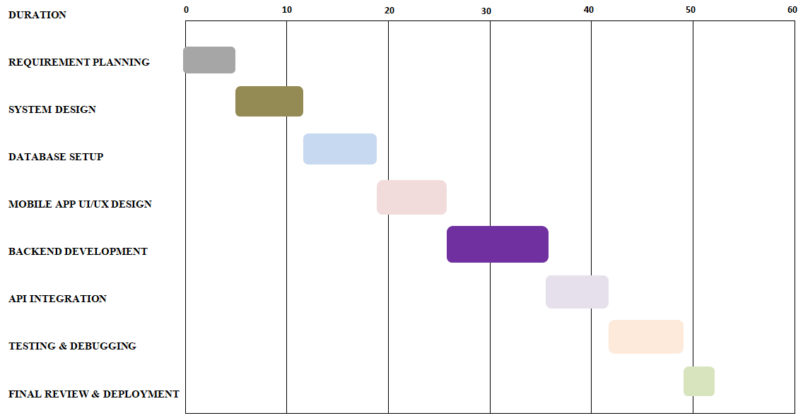

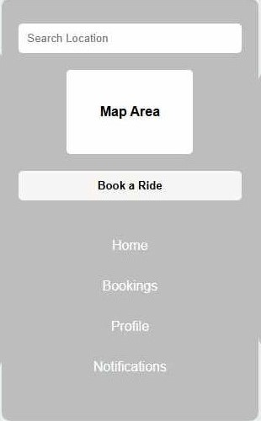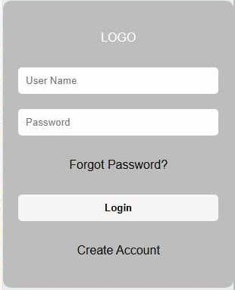**22**

**System Prototype**

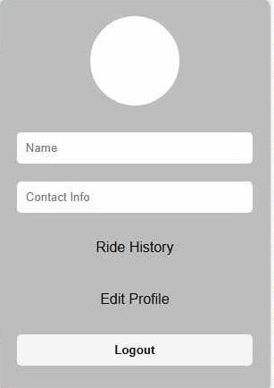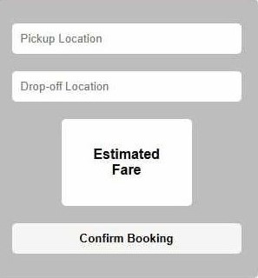

**Search Screen**

**Login Screen**

**Booking Details Screen**

**Profile Screen**

**Booking Details Screen**

**Profile Screen**

**23**

**Data Flow Diagram**

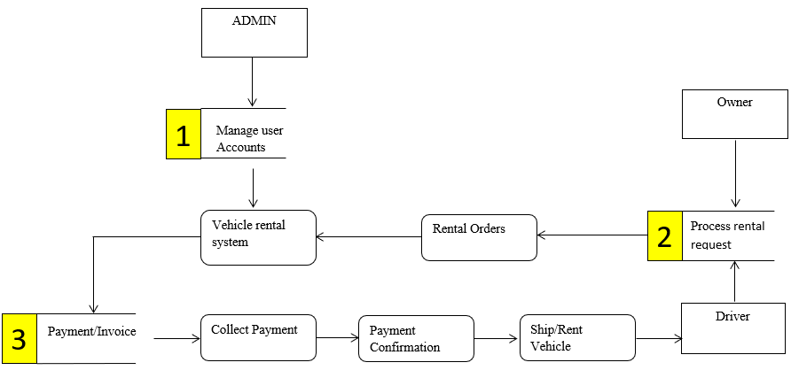

**24**

**Data Flow Diagram Level 0**

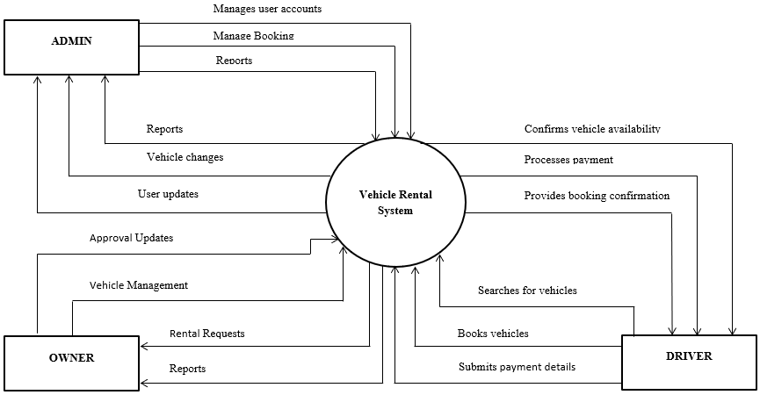

**25**

**ER Diagram**

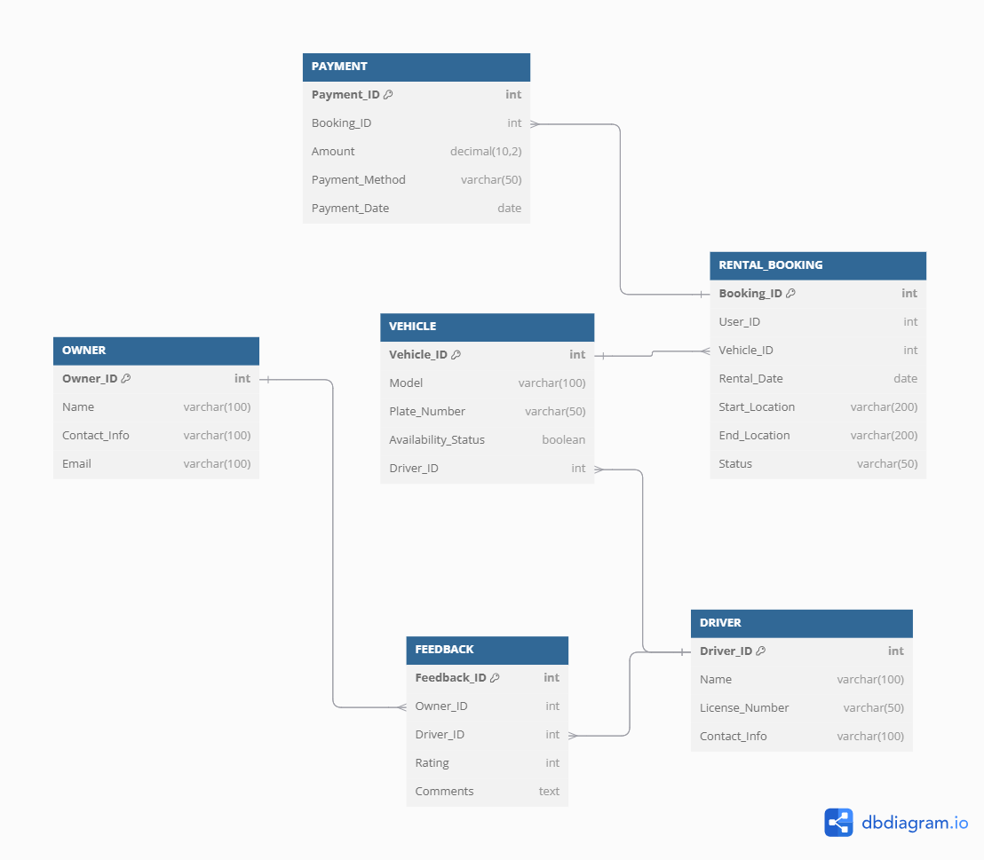



**26**

**System Architecture**

The Vehicle Rental System with Mobile App Support utilizes the layered architecture which enhances customer convenience by allowing users to easily book, manage, and pay for rentals through a mobile app. It streamlines operations by automating booking, payment, and vehicle management, reducing manual work and minimizing booking conflicts through real-time data updates. The modular architecture ensures scalability, allowing new features to be added seamlessly as the business grows. Integrated notifications improve customer communication, while the reporting service provides valuable insights into customer preferences and business trends. Secure user management and payment features also build customer trust, addressing the need for data privacy and security in today’s digital landscape.

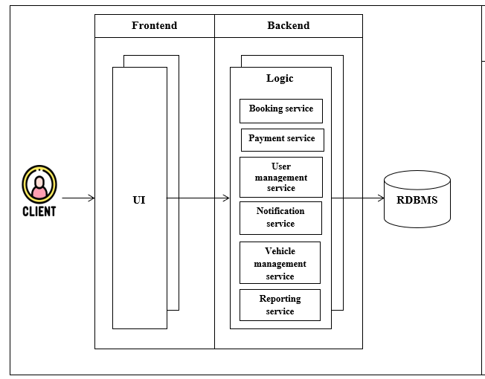



**27**

**PERT**

5

0

Requirement Planning

5

123222

System Design

19

123222

Database Setup

26

19

Mobile App UI/UX Design

36

26

Backend Development

41

36

API Integration

41

49

Testing & Debugging

52

49

Final Review & Deployment

**28**

**CPM**

5

A

7

B

7

C

7

D

10

E

5

F

8

G

3

H

* **Critical Path (CPM):**  A > B > C > D > E > F > G > H
* **Total Duration of Critical Path:**  52 days
* **No Slack on the Critical Path**

**29**

**COST-BENEFIT ANALYSIS**

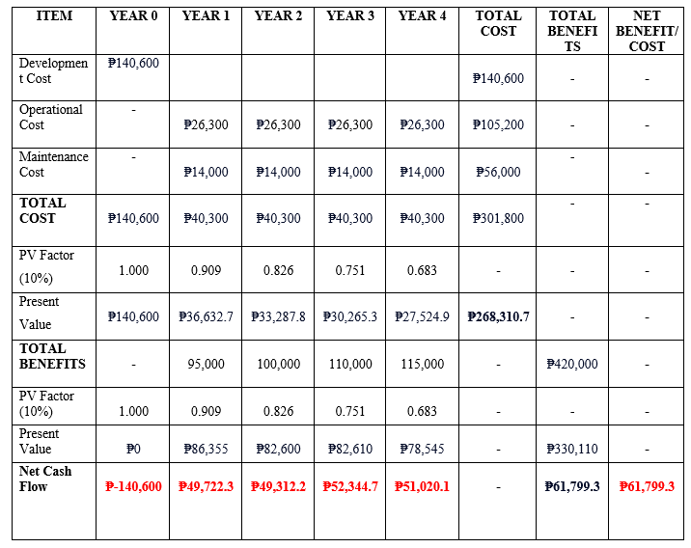

**30**

**RETURN OF INVESTMENT**

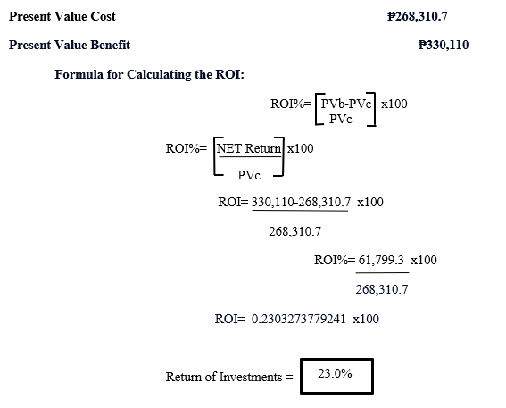

**31**

CHAPTER III

TREATMENT OF DATA

**FINDINGS**

**Figure 1. Survey Responses on Accurate Vehicle Recommendations Based on User Preferences**

As shown in the figure above, the majority of respondents (15 out of 15, or 100%) expressed a positive outlook on the system providing accurate vehicle recommendations based on user preferences. Among them, 10 respondents (67%) strongly agreed, while 5 respondents (33%) agreed with the statement. Notably, no respondents selected neutral, disagree, or strongly disagree, indicating unanimous support for this feature.

**32**

### Figure 2. Survey Responses on Meeting the Needs of Customers Seeking Vehicle Rentals for Different Purposes

As shown in the figure above, the majority of respondents (15 out of 15, or 100%) believe that the system will effectively meet the needs of customers seeking vehicle rentals for various purposes. Among them, 9 respondents (60%) strongly agreed, while 6 respondents (40%) agreed with the statement. Notably, no respondents selected neutral, disagree, or strongly disagree, indicating strong confidence in the system's capability to cater to diverse customer requirements.

**33**

### Figure 3. Survey Responses on the Mobile App's Ease of Use for First-Time Users

As shown in the figure above, all respondents (15 out of 15, or 100%) expressed a positive perception of the mobile app’s ease of use for first-time users. Among them, 10 respondents (67%) agreed, while 5 respondents (33%) strongly agreed with the statement. Notably, no respondents selected neutral, disagree, or strongly disagree, indicating unanimous confidence in the app's user-friendly design.

**34**

### Figure 4. Survey Responses on the Interface's Ease of Searching and Booking Vehicles

As shown in the figure above, all respondents (15 out of 15, or 100%) positively rated the interface for ease of searching and booking vehicles. Among them, 11 respondents (73%) strongly agreed, while 4 respondents (27%) agreed with the statement. Notably, no respondents selected neutral, disagree, or strongly disagree, reflecting unanimous support for the interface's usability.

**35**

### Figure 5. Survey Responses on the App Requiring Minimal Technical Skills to Operate Effectively

As shown in the figure above, the majority of respondents (14 out of 15, or 94%) expressed a positive perception of the app’s usability, indicating that minimal technical skills are required to operate it effectively. Among them, 7 respondents (47%) strongly agreed, and another 7 respondents (47%) agreed. However, 1 respondent (6%) disagreed, suggesting that some minor concerns exist. Notably, no respondents selected neutral or strongly disagree, demonstrating overall confidence in the app's accessibility.

**36**

### Figure 6. Survey Responses on the System's Consistent and Uninterrupted Operation

As shown in the figure above, most respondents (15 out of 15, or 100%) believe the system will operate consistently without interruptions. Among them, 8 respondents (53%) strongly agreed, and 7 respondents (47%) agreed with the statement. However, 1 respondent (6%) disagreed, indicating minor concerns about potential interruptions. Notably, no respondents selected neutral or strongly disagree, reflecting overall confidence in the system's reliability.

**37**

### Figure 7. Survey Responses on the System's Security in Saving and Retrieving User and Booking Data

As shown in the figure above, the majority of respondents (15 out of 15, or 100%) expressed confidence in the system's ability to securely save and retrieve user and booking data. Among them, 13 respondents (87%) strongly agreed, and 2 respondents (13%) agreed with the statement. Notably, no respondents selected neutral, disagree, or strongly disagree, reflecting overall trust in the system's data protection capabilities.

**38**

### Figure 8. Survey Responses on the System's Quick Loading and Minimal User Waiting Time

As shown in the figure above, the majority of respondents (15 out of 15, or 100%) rated the system’s quick loading time positively. Among them, 10 respondents (67%) strongly agreed, while 4 respondents (27%) agreed with the statement. However, 1 respondent (6%) disagreed, indicating minor concerns about potential delays. Notably, no respondents selected neutral or strongly disagree, reflecting general confidence in the system's performance.

**39**

### Figure 9. Survey Responses on the System's Ability to Handle Multiple Users Efficiently

As shown in the figure above, most respondents (15 out of 15, or 100%) believe the system will handle multiple users efficiently. Among them, 12 respondents (79%) agreed, 1 respondent (6%) strongly agreed, and 1 respondent (6%) disagreed with the statement. Additionally, 1 respondent (6%) selected neutral, suggesting a small level of uncertainty. Notably, no respondents strongly disagreed, indicating general confidence in the system's ability to manage multiple users.

### Figure 10. Survey Responses on Future Updates Not Disrupting Existing System Functionality

As shown in the figure above, the majority of respondents (15 out of 15, or 100%) believe that future updates to the system will not disrupt its existing functionalities. Among them, 12 respondents (80%) agreed, while 3 respondents (20%) strongly agreed with the statement. Notably, no respondents selected neutral, disagree, or strongly disagree, reflecting strong confidence in the system's stability during updates.

**40**

### Figure 11. Survey Responses on the System's Ease of Modification or Enhancement

As shown in the figure above, the majority of respondents (15 out of 15, or 100%) believe that the system will be easy to modify or enhance as needed. Among them, 10 respondents (67%) agreed, while 5 respondents (33%) strongly agreed with the statement. Notably, no respondents selected neutral, disagree, or strongly disagree, indicating strong confidence in the system's flexibility for future modifications or enhancements.

**41**

### Figure 12. Survey Responses on the System's Ability to Ensure Privacy of User and Payment Data

As shown in the figure above, the majority of respondents (15 out of 15, or 100%) expressed confidence that the system will ensure the privacy of user and payment data. Among them, 11 respondents (73%) strongly agreed, while 4 respondents (27%) agreed with the statement. Notably, no respondents selected neutral, disagree, or strongly disagree, indicating strong trust in the system's ability to protect user and payment data.

**42**

### Figure 13. Survey Responses on the System's Effectiveness in Preventing Unauthorized Access to Sensitive Data

As shown in the figure above, the majority of respondents (15 out of 15, or 100%) believe that the system will effectively prevent unauthorized access to sensitive data. Among them, 10 respondents (67%) strongly agreed, while 5 respondents (33%) agreed with the statement. Notably, no respondents selected neutral, disagree, or strongly disagree, reflecting strong confidence in the system's security measures.

**43**

### Figure 14. Survey Responses on the Mobile App's Seamless Functionality Across Different Devices and Operating Systems

As shown in the figure above, the majority of respondents (15 out of 15, or 100%) believe that the mobile app will work seamlessly across different devices and operating systems. Among them, 12 respondents (80%) strongly agreed, while 3 respondents (20%) agreed with the statement. Notably, no respondents selected neutral, disagree, or strongly disagree, indicating strong confidence in the app's cross-platform compatibility.

**44**

### Figure 15. Survey Responses on the System's Proper Functionality Across Different Mobile Platforms

As shown in the figure above, the majority of respondents (15 out of 15, or 100%) believe that the system will function properly across different mobile platforms. Among them, 11 respondents (73%) agreed, and 4 respondents (27%) strongly agreed with the statement. Notably, no respondents selected neutral, disagree, or strongly disagree, indicating strong confidence in the mobile app's compatibility across various devices and operating systems.

### ****45****

### ****PROJECTION****

### ****Figure 1: Survey Responses on Accurate Vehicle Recommendations Based on User Preferences****

**Projection:**  
Given the unanimous support for accurate vehicle recommendations, the researchers will integrate a feature that provides personalized vehicle suggestions based on individual user preferences. This feature will enhance the user experience by displaying the most relevant vehicle options upon login, increasing user satisfaction and engagement.

### ****Figure 2: Survey Responses on Meeting the Needs of Customers Seeking Vehicle Rentals for Different Purposes****

**Projection:**  
The researchers will ensure that the system accommodates a variety of customer needs by offering flexible vehicle options. This includes categorizing vehicles by usage type (e.g., for business, leisure, or special events) to allow users to easily find the best-suited vehicle for their specific purpose, thereby improving the app's adaptability.

### ****Figure 3: Survey Responses on the Mobile App's Ease of Use for First-Time Users****

**Projection:**  
Since first-time users find the app easy to navigate, the researchers will maintain the simplicity and user-friendly design of the interface. This will ensure that even novice users can access all

**46**

features with minimal effort, enhancing user retention and positive reviews for the app's usability.

### ****Figure 4: Survey Responses on the Interface's Ease of Searching and Booking Vehicles****

**Projection:**  
The researchers will further refine the app's search and booking functionality, ensuring it remains intuitive and efficient. Features like advanced search filters and quick booking options will be optimized to minimize user effort and reduce booking time, making the process seamless for users.

### ****Figure 5: Survey Responses on the App Requiring Minimal Technical Skills to Operate Effectively****

**Projection:**  
Given the strong preference for minimal technical skills, the researchers will focus on maintaining a simple and intuitive interface that requires no technical expertise to operate. Tutorials and helpful prompts may also be included to guide users, ensuring accessibility for all demographics.

### ****Figure 6: Survey Responses on the System's Consistent and Uninterrupted Operation****

**Projection:**  
To meet user expectations for system reliability, the researchers will prioritize robust server infrastructure and real-time monitoring systems. This will minimize downtime and ensure the app

**47**

operates consistently, even under heavy usage, fostering trust and reliability.

### ****Figure 7: Survey Responses on the System's Security in Saving and Retrieving User and Booking Data****

**Projection:**  
The researchers will implement advanced encryption and security protocols to protect sensitive user and booking data. Features such as two-factor authentication (2FA) will be added to enhance security and build user trust, ensuring data privacy at all stages.

### ****Figure 8: Survey Responses on the System's Quick Loading and Minimal User Waiting Time****

**Projection:**  
To address concerns about waiting times, the researchers will optimize the system for faster loading speeds. This could include improvements in server response times, image compression, and efficient database queries to ensure the app provides a seamless experience with minimal delay.

### ****Figure 9: Survey Responses on the System's Ability to Handle Multiple Users Efficiently****

**Projection:**  
To ensure smooth operation during peak usage, the researchers will implement scalable cloud infrastructure and load balancing techniques. This will allow the system to handle a large number

**48**

of simultaneous users, ensuring that performance remains unaffected by traffic spikes.

### ****Figure 10: Survey Responses on Future Updates Not Disrupting Existing System Functionality****

**Projection:**  
The researchers will adopt a careful and tested update management approach, including extensive testing in staging environments before deploying updates. This will prevent disruptions and ensure that new features or bug fixes do not negatively impact the existing functionality.

### ****Figure 11: Survey Responses on the System's Ease of Modification or Enhancement****

**Projection:**  
The researchers will design the system with flexibility in mind, ensuring that it can be easily modified or enhanced as user needs evolve. Modular architecture and well-documented APIs will enable smooth future updates and feature additions, ensuring longevity and adaptability.

### ****Figure 12: Survey Responses on the System's Ability to Ensure Privacy of User and Payment Data****

### ****49****

**Projection:**  
To further bolster trust, the researchers will implement end-to-end encryption for all user and payment data. Regular security audits and compliance with privacy regulations (such as GDPR) will be conducted to ensure the system remains secure and protects user privacy.

### ****Figure 13: Survey Responses on the System's Effectiveness in Preventing Unauthorized Access to Sensitive Data****

**Projection:**  
The researchers will implement multi-layered security features to prevent unauthorized access. These could include role-based access control (RBAC), continuous monitoring for suspicious activity, and strong password policies to enhance the system's security.

### ****Figure 14: Survey Responses on the Mobile App's Seamless Functionality Across Different Devices and Operating Systems****

**Projection:**  
To ensure cross-platform compatibility, the researchers will test the mobile app on a wide range of devices and operating systems. Regular updates and compatibility checks will ensure that the app works seamlessly, providing a consistent user experience across devices.

### ****Figure 15: Survey Responses on the System's Proper Functionality Across Different Mobile Platforms****

### 50

**Projection:**  
The researchers will ensure that the system is fully optimized for different mobile platforms, including iOS and Android. Cross-platform frameworks and platform-specific testing will ensure the system functions properly, regardless of the user’s device or operating system.

**51**

**CHAPTER IV**

**CONCLUSION AND RECOMMENDATIONS**

The Vehicle Rental System with Mobile App Support addresses the limitations of traditional vehicle rental services by leveraging technology to enhance both customer experience and operational efficiency.

**CONCLUSION**

The main purpose of our project is to develop an integrated platform that simplifies the vehicle rental process by providing users with a convenient mobile application for booking, managing rentals, and making payments, while enabling the company to streamline operations and improve service delivery. Through a user-friendly mobile application, the system simplifies the rental process, offering features such as real-time vehicle availability, seamless reservation, and secure payment processing. This streamlined approach reduces wait times, eliminates cumbersome paperwork, and provides customers with greater accessibility and control over their rentals. Moreover, the system benefits operators by optimizing resource management, improving customer satisfaction, and providing data-driven insights to enhance service delivery. By bridging the gap between customer expectations and service efficiency, the project significantly contributes to the modernization of the automobile rental sector.

**RECOMMENDATION**

**52**

To enhance the effectiveness of the Vehicle Rental System with Mobile App Support, several recommendations are proposed. First, the app’s interface and usability should be continuously improved by incorporating customer feedback, ensuring a seamless and user-friendly experience. Advanced features such as GPS tracking for efficient fleet management, real-time customer support via chatbots or live agents, and loyalty programs should be integrated to improve functionality and user engagement. Additionally, the system should be designed for scalability and flexibility to accommodate future growth in user and vehicle numbers. Data security must be prioritized by implementing robust encryption and safeguarding user information to build and maintain customer trust. Furthermore, promoting the use of eco-friendly vehicles such as electric or hybrid options can contribute to sustainability goals. Lastly, periodic system audits should be conducted to assess performance and implement updates, ensuring the system remains aligned with technological advancements and customer needs.